CS 255 System Design Document

UML Diagrams

UML Use Case Diagram
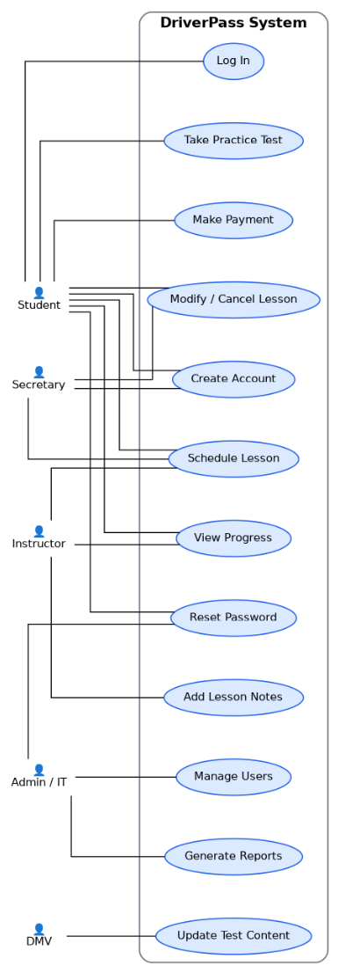
This diagram shows how different users interact with the DriverPass system. Customers can create accounts, log in, take practice tests, schedule lessons, and track their progress. Instructors can manage lessons and view student progress. Admin staff handle user management, password resets, and reports. The DMV provides updated test content. This setup ensures that all users have the tools they need to help students prepare for their driving test.

UML Activity Diagrams
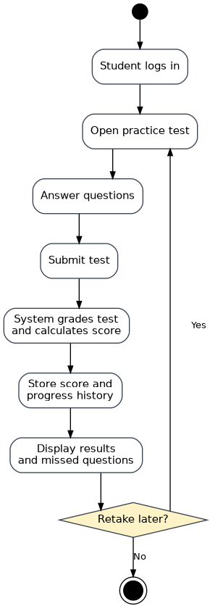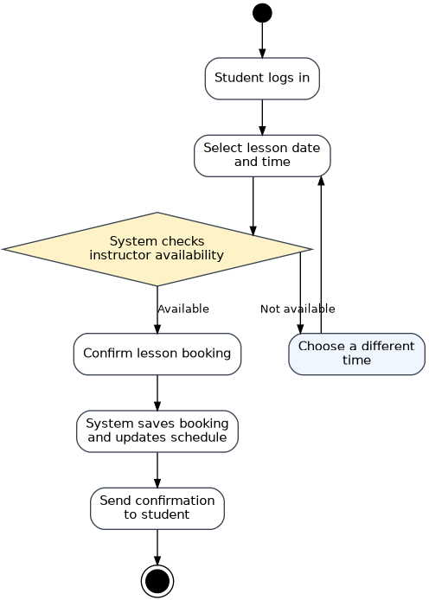
The activity diagrams show how key tasks are completed step by step. One diagram shows how a user schedules a driving lesson, starting with logging in, choosing a time, confirming the booking, and receiving confirmation. The second diagram shows how a user takes a practice test, submits answers, and receives results. These diagrams help ensure the system is simple to use and follows a clear process.

UML Sequence Diagram
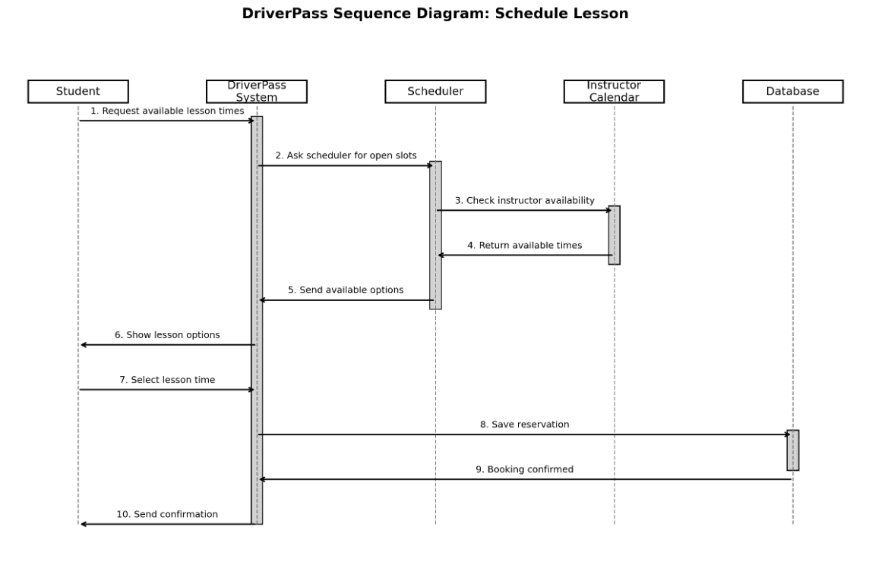
The sequence diagram shows how different parts of the system work together when scheduling a lesson. The user selects a lesson time, the system checks availability, confirms the booking, and updates the schedule. This diagram helps show how information flows through the system to complete a task.

UML Class Diagram
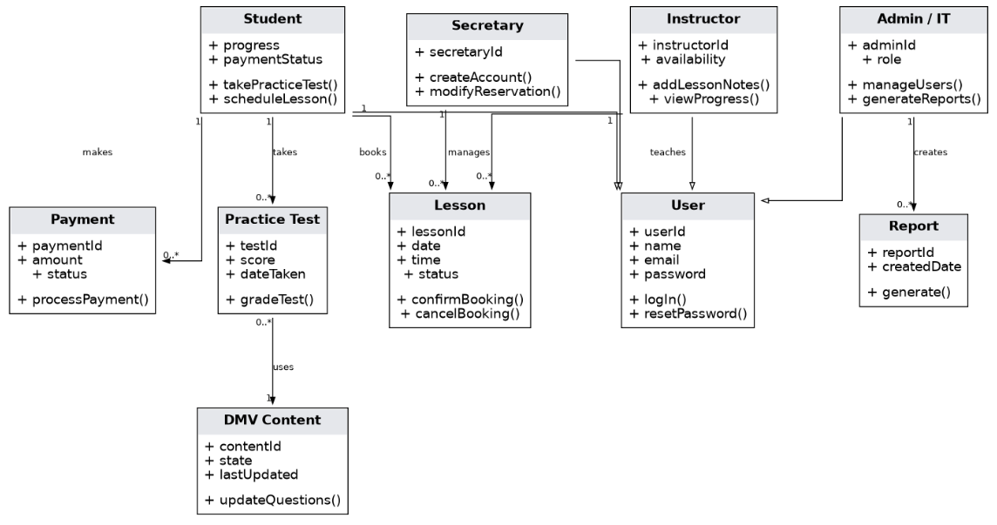
The class diagram shows the main parts of the system, such as users, lessons, tests, and schedules. It also shows how these parts are connected and what information they store. This ensures the system is organized and supports features like scheduling, progress tracking, and account management.

Technical Requirements
The DriverPass system will be a web-based platform that is also accessible on mobile devices. It will require a database to store user accounts, test results, lesson schedules, and progress data. The system should support multiple users at the same time and load quickly to provide a smooth experience.
The system will use server-side technology to process requests and manage communication between users and the database. Security features such as encrypted connections and secure login will be included to protect user data. The system should also be scalable so it can support more users as it grows. Regular updates will be needed to keep practice test content accurate and aligned with DMV standards.

